LEC 8/14/2016

August 2016 LEC - Denbigh Christian Academy, 8/16/16 at 17:00

Called to Order and Obligation given by Lodge Chief at 5:04

Motion - Approve the June 2016 minutes as written
Discussion - Available on the website, please look at them (like you are now)! Minutes were read for the LEC.
Vote - Carries

Treasurer Report
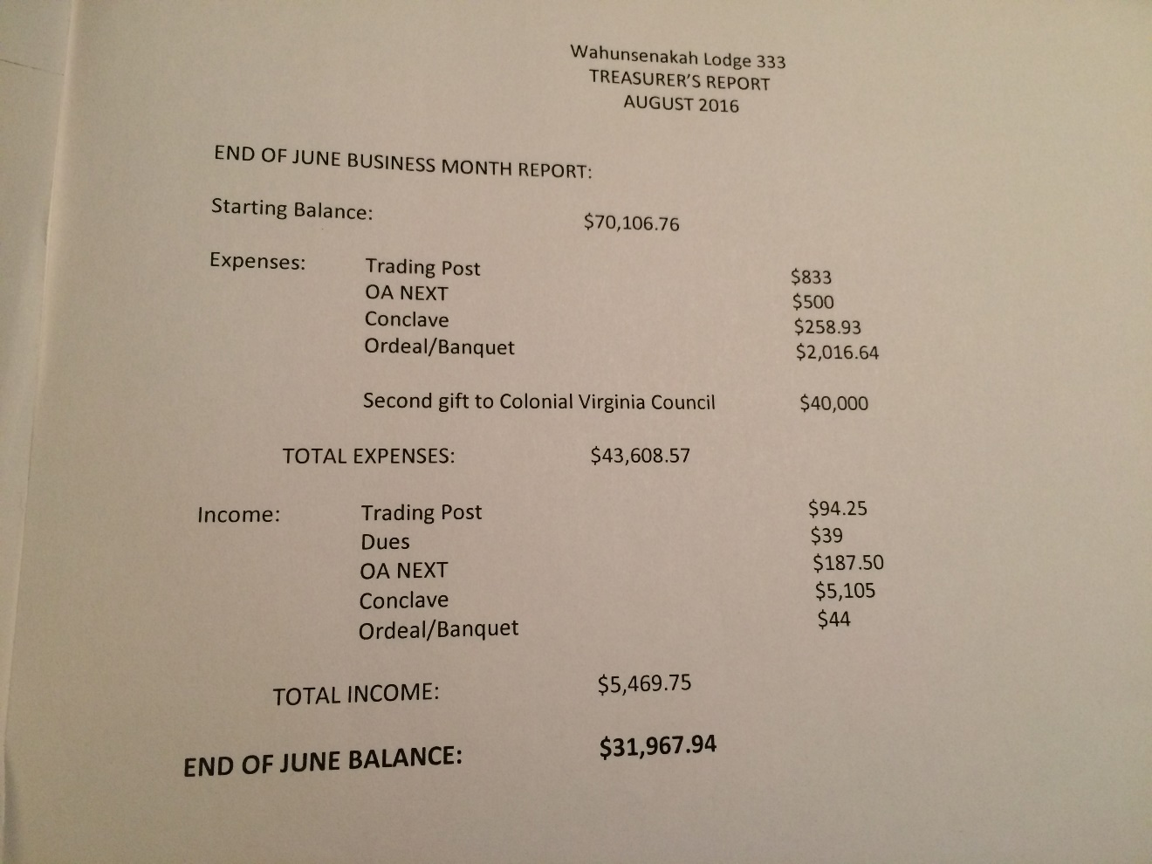

Motion - Approve the Treasurer Report
Discussion - Very great and comprehensive.
Vote - Carries

Membership Report
521 paid dues this year

Officer Reports
- First Vice Chief: Working on the LLDC
- Second Vice Chief of Program: Working on job list for next service weekend, to be distributed soon
- Second Vice Chief of Administration: Trying to fill chairman positions and is looking for youth to be next Conclave Contingent Leader
- Secretary: Minutes will posted within 3 days

Committee Reports
- Vigil Selection: Explained in later business
- Communications: Website design changes! Newsletter being discussed for distribution next service weekend
- Service: Partial list of jobs for Ordeal. Committee is being organized with a vision, mission statement, and goals - including an adult skills inventory for organizing projects better.
- Elangomat: Waiting for job list. Red Sashes to be distributed next service weekend. Advisor and Chair were awarded Red Sashes at the LEC.
- Insignia: Working on patches for 2017. Idea submissions welcome. Designs to be presented on October meeting.
- Camping Promotions: Summer Camp presentation being worked on for distribution to chapters.
- AIA: Building dance team - 2 youth and 4 adults interested in helping. Leadership has a lot of experience and willing to help.
- TP: 20th Anniversary Flaps are in! 45 extras for sale at Summer Service.

Chapter Reports (On the next page)
- Kecoughtan: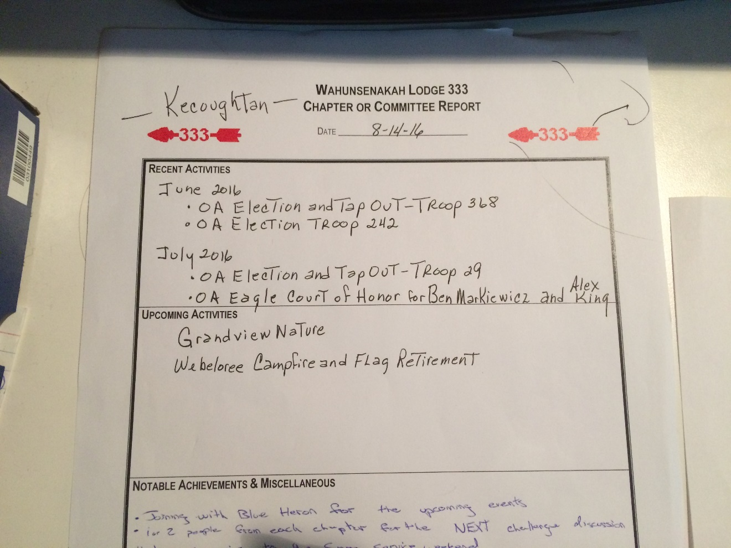

- Nansemond: Starting AIA committee. Planning chapter day(s) of service soon
- Nottoway: Unit election and Camping Promotions for T125; working with Blue Heron for helping with Fellowship
- Piankatank: 14 members at past meeting; elections and callouts completed for T221; food drive last month for fish

Old Business
- Report for PRISM: 7 went. Really good time.
- Report for NEXT: 5 day experience, learned new things to help with Lodge. All three of the below are below Gold level Journey to Excellence standards
  - Unit Elections
  - Membership
  - Event Participation
- Chapter chiefs: 1-2 peeps per chapter to go to NEXT challenge discussion next service weekend. May last a few hours.
- New Committees: Need to be filled. Looking for adult and youth.
- Vigil: Due August 19. (See EMAIL)

New Business
- SSW: September 16- 18. Service Committee to perform "Messengers of Peace" program again in the same area and may expand to other areas.
- Joint Fall Fellowship: The Lodge Chiefs of Wahunsenakah and Blue Heron talked: At Pipsico (think mini CONCLAVE) with Conclave games, where each Lodge's chapters play against each other. Not as much training - training of unit elections and advisors.. Iron Duck, monopoly game. Concert at night. Patch Auction.
- Open Committees: (Continued on the next page)
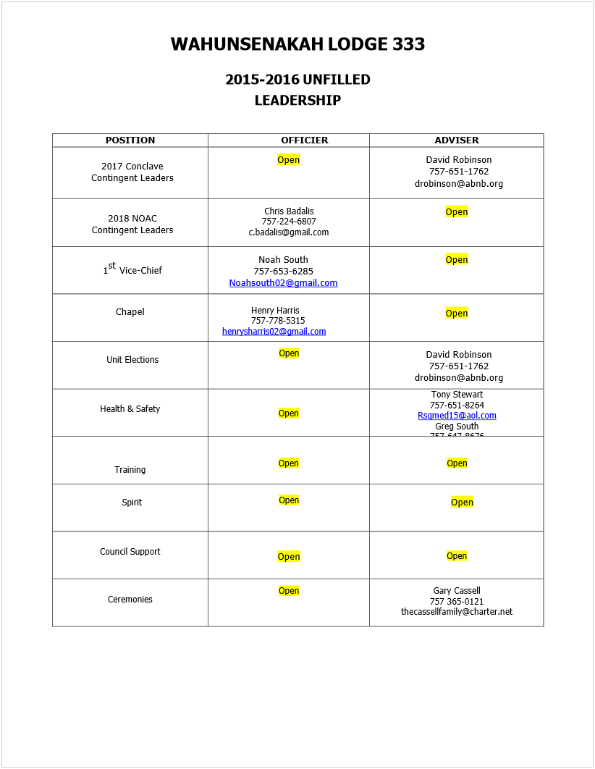

- Annual Goals: Will be posted online within a week. Will be voted on next LEC.
- New Treasurer Reports: Anyone who deals with money coming in our out needs to be reported to Treasurer, Staff Advisor, and Zach. Better stewardship of funds. Outside of events and dues, no OA money accepted at store without being approved by Treasurer+.
  - TP: Money needs to be logged in a monthly/weekly report to be separated from Engraving money.
- Silver Duck Nominations: Due November 3 at Noon.
- Founder Award: Due October 15 at Noon.
- LLDC: November 18-20. Location TBD.
- Holiday Banquet: Kecoughtan youth being sought out to help and Advisors are looking for locations.
- The Council of Chiefs will be at Pipsico.
- Ranger Joe's Totem Poles: Ranger Joe recovered some totem poles from Bayport, and is offering them to the Lodge.

Motion - Keep the two totem poles from Ranger Joe
DISCUSSION - "Where be kept?" "Hopefully somewhere where they'll be used!" "Will need adult help to get them out of camp and places for it." Council office? At camps? "Have them together so when you decide to know what to do with them you can."
Vote - Carries

- Other New Business:
  - SSW: want chapters and two youth and one adult to go over Lodge Rules and revise them (usually not chief). In need of updates.
  - Vigil Selection: At Denbigh Christain Academy. Due date extended. Nominations must be in Morris's hand by 19th.
  - National Programs Promotion
  - Treasurer: This is new - we never really knew what the money was. Scott is allowing us to see our money. Accountability for Lodge and Chapters. Want to have checking between Council and Lodge Treasurer for matchup.
  - Patches for Jambo?

Motion - To make a Jamboree patch for the lodge and council?
DISCUSSION - "Not unless we get a design!...we need a theme." Get Conclave theme early so we can do something with it early! IF executive board wants Jambo patch. "Single flap or flap with an X? I personally don't like Xs, but they go pretty big at events."
Vote - Carries

"Think about working on a design! No due dates right now, but worry about Conclave first!"

Staff Advisor's Minute
Bring in people (tribe people, service ops.) to chapter to enhance program! Adults and advisors: Remind the youth to have fun.

Advisor's Minute
5 went to NEXT. Will help make our Lodge a lot better. Talk more about it at service weekend. Minutes: Youth need to be read beforehand. Email minutes to youth to read. AIA: Advisor is awesome resource. AIA is big part of what we do.

Chief's Minute
National Chief says we need to have more fun! What creative and fun ways can we add to chapter meetings and service weekends?

Meeting closed with OA Song at 18:03

