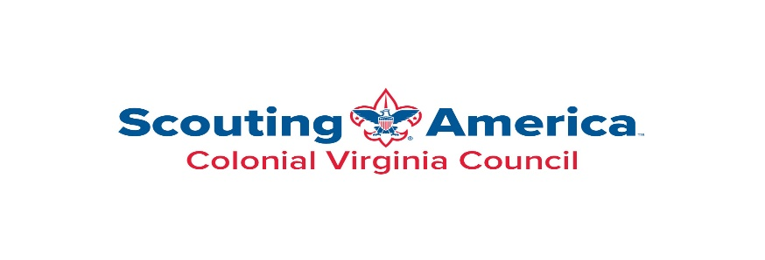
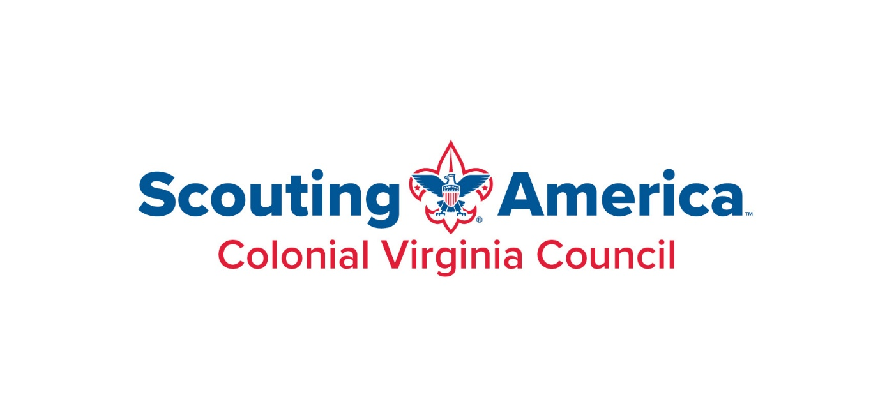
08 March 2025
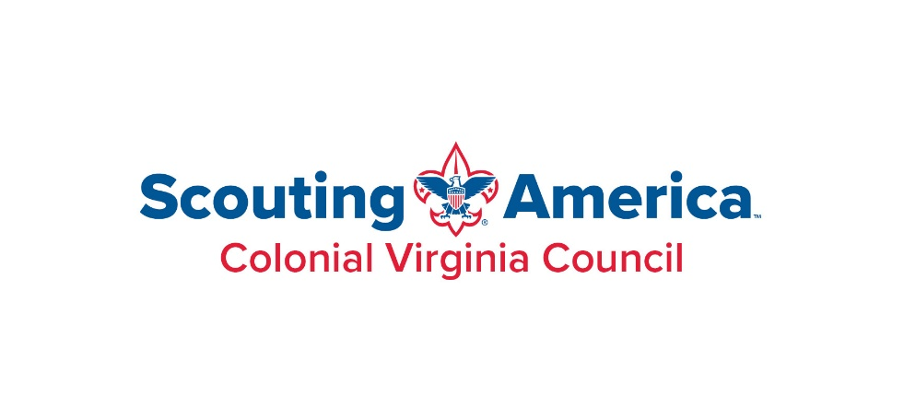
Dear PRINCIPAL:

I am writing you on behalf of the Wahunsenekah Lodge 333 of the Order of the Arrow, in cooperation with the Colonial Virginia Council, Boy Scouts of America. The Order of the Arrow is Scouting’s National Honor Society in which young men and women, who have excelled in their Troops in leadership roles, are elected by their peers and granted the privilege of membership.

Every year the Order of the Arrow in the state of Virginia hosts a Section Conclave (a gathering of all of the Order of the Arrow lodges in the Section). It is a weekend full of meeting new peers from across the state, as well as sitting in on training classes during the Saturday sessions, where they learn about leadership techniques, and working with people through various situations.

I am writing to you because, Wahunsenekah Lodge is sending a contingent of Scouts to this event. The event has averaged over 1000 participants the last few years. This year the event is in Surry, VA , and will require some travel, the contingent will be departing Friday April 25th to ensure the safety of our members that will be traveling. Considering this, we respectfully request that you excuse your student, _______________________, from this single day of their studies. I can assure you, however, that it will be a weekend well spent meeting peers in other areas of the state, and learning about leadership and organization.

Thank you again for your cooperation, and if you have any questions feel free to contact me at brian.rabidou@scouting.org .

Sincerely,
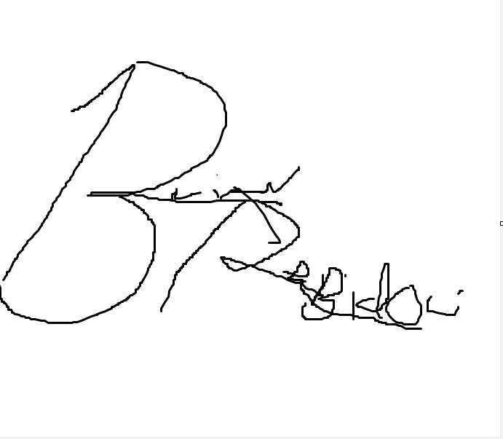

Brian Rabidou, District Executive
Colonial Virginia Council
Boy Scouting America

11834 Canon Blvd, Suite L

Newport News, Virginia 23606
757-595-3356
www.cvcboyscouts.org

